**MACHINE LEARNING**

**LAB ASSIGNMENT 2**

**GITHUB LINK:**

**DATASET:**

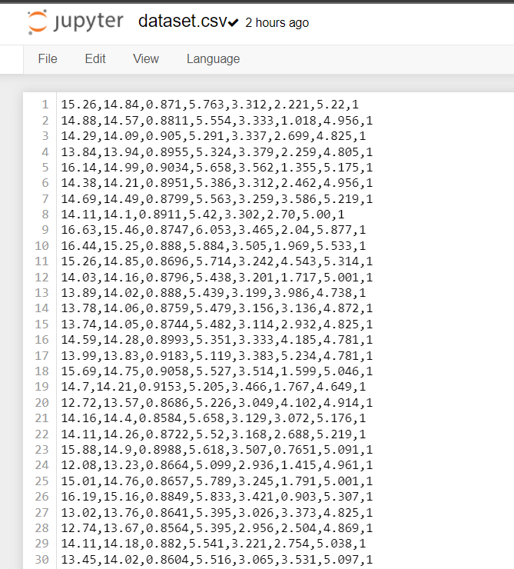

**CODE:**

#importing required libraries

from random import seed

from random import randrange

from random import random

from csv import reader

from math import exp

# Load a CSV file

def load_csv(filename):

dataset = list()

with open(filename, 'r') as file:

csv_reader = reader(file)

for row in csv_reader:

if not row:

continue

dataset.append(row)

return dataset

# Convert string column to float

def str_column_to_float(dataset, column):

for row in dataset:

row[column] = float(row[column].strip())

# Convert string column to integer

def str_column_to_int(dataset, column):

class_values = [row[column] for row in dataset]

unique = set(class_values)

lookup = dict()

for i, value in enumerate(unique):

lookup[value] = i

for row in dataset:

row[column] = lookup[row[column]]

return lookup

# Find the min and max values for each column

def dataset_minmax(dataset):

minmax = list()

stats = [[min(column), max(column)] for column in zip(*dataset)]

return stats

# Rescale dataset columns to the range 0-1

def normalize_dataset(dataset, minmax):

for row in dataset:

for i in range(len(row)-1):

row[i] = (row[i] - minmax[i][0]) / (minmax[i][1] - minmax[i][0])

# Split a dataset into k folds

def cross_validation_split(dataset, n_folds):

dataset_split = list()

dataset_copy = list(dataset)

fold_size = int(len(dataset) / n_folds)

for i in range(n_folds):

fold = list()

while len(fold) < fold_size:

index = randrange(len(dataset_copy))

fold.append(dataset_copy.pop(index))

dataset_split.append(fold)

return dataset_split

# Calculate accuracy percentage

def accuracy_metric(actual, predicted):

correct = 0

for i in range(len(actual)):

if actual[i] == predicted[i]:

correct += 1

return correct / float(len(actual)) * 100.0

# Evaluate an algorithm using a cross validation split

def evaluate_algorithm(dataset, algorithm, n_folds, *args):

folds = cross_validation_split(dataset, n_folds)

scores = list()

for fold in folds:

train_set = list(folds)

train_set.remove(fold)

train_set = sum(train_set, [])

test_set = list()

for row in fold:

row_copy = list(row)

test_set.append(row_copy)

row_copy[-1] = None

predicted = algorithm(train_set, test_set, *args)

actual = [row[-1] for row in fold]

accuracy = accuracy_metric(actual, predicted)

scores.append(accuracy)

return scores

# Calculate neuron activation for an input

def activate(weights, inputs):

activation = weights[-1]

for i in range(len(weights)-1):

activation += weights[i] * inputs[i]

return activation

# Transfer neuron activation

def transfer(activation):

return 1.0 / (1.0 + exp(-activation))

# Forward propagate input to a network output

def forward_propagate(network, row):

inputs = row

for layer in network:

new_inputs = []

for neuron in layer:

activation = activate(neuron['weights'], inputs)

neuron['output'] = transfer(activation)

new_inputs.append(neuron['output'])

inputs = new_inputs

return inputs

# Calculate the derivative of an neuron output

def transfer_derivative(output):

return output * (1.0 - output)

# Backpropagate error and store in neurons

def backward_propagate_error(network, expected):

for i in reversed(range(len(network))):

layer = network[i]

errors = list()

if i != len(network)-1:

for j in range(len(layer)):

error = 0.0

for neuron in network[i + 1]:

error += (neuron['weights'][j] * neuron['delta'])

errors.append(error)

else:

for j in range(len(layer)):

neuron = layer[j]

errors.append(neuron['output'] - expected[j])

for j in range(len(layer)):

neuron = layer[j]

neuron['delta'] = errors[j] * transfer_derivative(neuron['output'])

# Update network weights with error

def update_weights(network, row, l_rate):

for i in range(len(network)):

inputs = row[:-1]

if i != 0:

inputs = [neuron['output'] for neuron in network[i - 1]]

for neuron in network[i]:

for j in range(len(inputs)):

neuron['weights'][j] -= l_rate * neuron['delta'] * inputs[j]

neuron['weights'][-1] -= l_rate * neuron['delta']

# Train a network for a fixed number of epochs

def train_network(network, train, l_rate, n_epoch, n_outputs):

for epoch in range(n_epoch):

for row in train:

outputs = forward_propagate(network, row)

expected = [0 for i in range(n_outputs)]

expected[row[-1]] = 1

backward_propagate_error(network, expected)

update_weights(network, row, l_rate)

# Initialize a network

def initialize_network(n_inputs, n_hidden, n_outputs):

network = list()

hidden_layer = [{'weights':[random() for i in range(n_inputs + 1)]} for i in range(n_hidden)]

network.append(hidden_layer)

output_layer = [{'weights':[random() for i in range(n_hidden + 1)]} for i in range(n_outputs)]

network.append(output_layer)

return network

# Make a prediction with a network

def predict(network, row):

outputs = forward_propagate(network, row)

return outputs.index(max(outputs))

# Backpropagation Algorithm With Stochastic Gradient Descent

def back_propagation(train, test, l_rate, n_epoch, n_hidden):

n_inputs = len(train[0]) - 1

n_outputs = len(set([row[-1] for row in train]))

network = initialize_network(n_inputs, n_hidden, n_outputs)

train_network(network, train, l_rate, n_epoch, n_outputs)

predictions = list()

for row in test:

prediction = predict(network, row)

predictions.append(prediction)

return(predictions)

# Test Backprop on Seeds dataset

seed(1)

# load and prepare data

filename = 'dataset.csv'

dataset = load_csv(filename)

for i in range(len(dataset[0])-1):

str_column_to_float(dataset, i)

# convert class column to integers

str_column_to_int(dataset, len(dataset[0])-1)

# normalize input variables

minmax = dataset_minmax(dataset)

normalize_dataset(dataset, minmax)

# evaluate algorithm

n_folds = 5

l_rate = 0.3

n_epoch = 500

n_hidden = 5

scores = evaluate_algorithm(dataset, back_propagation, n_folds, l_rate, n_epoch, n_hidden)

# printing the final accuracy and score

print('Scores: %s' % scores)

print()

print('Mean Accuracy: %.3f%%' % (sum(scores)/float(len(scores))))

**SCREENSHOTS:**

